This is a reflex game which will test your patience, vision and timing senses.

Objective:
Students will present their html and JavaScript knowledge through real project design.

Create JavaScript Game Layout – (See sample below)
- Study all the JavaScript practices and projects, apply your knowledge to this assignment
- Use show time and moving object as base to create “your own” game
- Your game must including: image movement or change, proper instruction, and score
- Draw a flowchart to organize your logic
- Apply your programming skills to complete the task
Rubric:
- 5 pts Use “Start + Stop” or “Timer to start & end” Game
- 5 pts Has at least one moving object
- 5 pts Display Score/Proper Feedback
- 2 pts Clear Instruction
- 3 pts General Layout
- 50% If job end with any error at the status bar
Timeline:
- Day 1, decide your idea, and use flowchart or Pseudo Code to organize your game logic. Turn the flowchart/Pseudo Code in for a completion grade (10 points)
Sample Pseudo Code: http://www.unf.edu/~broggio/cop2221/2221pseu.htm
- Day 2, start to program your game
- Day 3, continue
- Day 4, continue
- Day 5, complete and turn in to Ms. Wu’s hand-in folder/ Reflex Game
Sample Game 1 (Scored 50%, no image/movement, no score/feedback, doesn’t reset/initialize score, very basic layout)

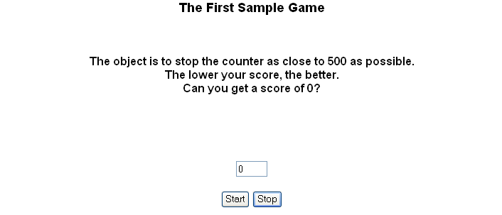
Sample Game 2 (Scored 70%, no image/movement with basic layout)

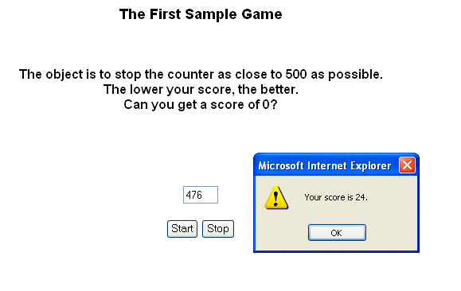
Sample Game 3: Scored 100%

